Day 4: Task 2: SQL Practical

In your groups, work together to answer the below questions. It may be of benefit if one of you shares your screen with the group and as a team answer / take screen shots from there.

Setting up the database:

- Download world_db(1) here
- Follow each step to create your database here

For each question I would like to see both the syntax used and the output.

- Count Cities in USA: Scenario: You've been tasked with conducting a demographic analysis of cities in the United States. Your first step is to determine the total number of cities within the country to provide a baseline for further analysis.

SELECT COUNT(*) AS CITYCOUNT
FROM city
WHERE CountryCode = 'USA';

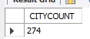

- Country with Highest Life Expectancy: Scenario: As part of a global health initiative, you've been assigned to identify the country with the highest life expectancy. This information will be crucial for prioritising healthcare resources and interventions.

SELECT LifeExpectancy, NAME
FROM country
ORDER BY LifeExpectancy DESC
LIMIT 1;
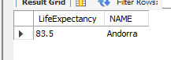

- "New Year Promotion: Featuring Cities with 'New : Scenario: In anticipation of the upcoming New Year, your travel agency is gearing up for a special promotion featuring cities with names including the word 'New'. You're tasked with swiftly compiling a list of all cities from around the world. This curated selection will be essential in creating promotional materials and enticing travellers with exciting destinations to kick off the New Year in style.

SELECT Name
FROM city
WHERE Name like 'new%'

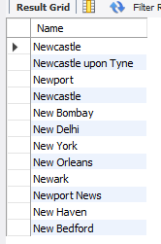

- Display Columns with Limit (First 10 Rows): Scenario: You're tasked with providing a brief overview of the most populous cities in the world. To keep the report concise, you're instructed to list only the first 10 cities by population from the database.

SELECT Name, Population
FROM city
ORDER BY Population DESC
LIMIT 10;

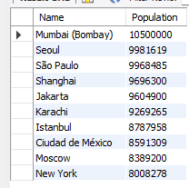

- Cities with Population Larger than 2,000,000: Scenario: A real estate developer is interested in cities with substantial population sizes for potential investment opportunities. You're tasked with identifying cities from the database with populations exceeding 2 million to focus their research efforts.

SELECT Name, Population
FROM city
WHERE Population > 2000000
ORDER BY Population DESC;

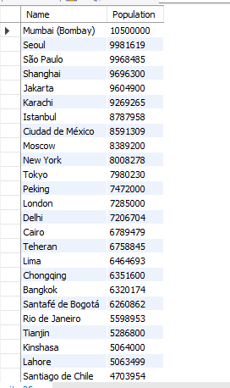

- Cities Beginning with 'Be' Prefix: Scenario: A travel blogger is planning a series of articles featuring cities with unique names. You're tasked with compiling a list of cities from the database that start with the prefix 'Be' to assist in the blogger's content creation process.

SELECT Name
FROM city
WHERE Name LIKE 'Be%';

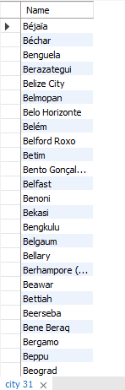

- Cities with Population Between 500,000-1,000,000: Scenario: An urban planning committee needs to identify mid-sized cities suitable for infrastructure development projects. You're tasked with identifying cities with populations ranging between 500,000 and 1 million to inform their decision-making process.

SELECT Name, Population
FROM city
WHERE Population BETWEEN 500000 AND 1000000;

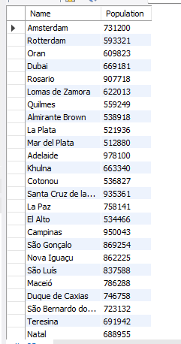

- Display Cities Sorted by Name in Ascending Order: Scenario: A geography teacher is preparing a lesson on alphabetical order using city names. You're tasked with providing a sorted list of cities from the database in ascending order by name to support the lesson plan.

SELECT Name
FROM city
ORDER BY Name ASC;

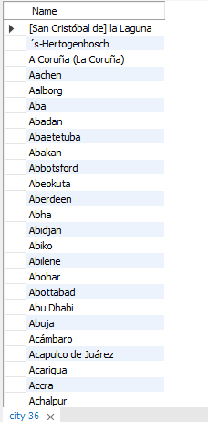

- Most Populated City: Scenario: A real estate investment firm is interested in cities with significant population densities for potential development projects. You're tasked with identifying the most populated city from the database to guide their investment decisions and strategic planning.

SELECT Population, NAME
FROM city
ORDER BY Population DESC
LIMIT 1;

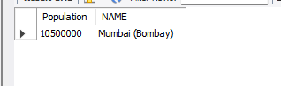

- City Name Frequency Analysis: Supporting Geography Education Scenario: In a geography class, students are learning about the distribution of city names around the world. The teacher, in preparation for a lesson on city name frequencies, wants to provide students with a list of unique city names sorted alphabetically, along with their respective counts of occurrences in the database. You're tasked with this sorted list to support the geography teacher.

SELECT Name, COUNT(*)
FROM City
GROUP BY Name
ORDER BY Name ASC;

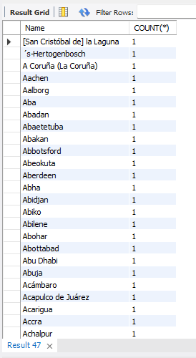

- City with the Lowest Population: Scenario: A census bureau is conducting an analysis of urban population distribution. You're tasked with identifying the city with the lowest population from the database to provide a comprehensive overview of demographic trends.

SELECT Name, Population
FROM City
ORDER BY Population ASC
LIMIT 1;

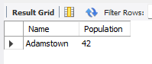

- Country with Largest Population: Scenario: A global economic research institute requires data on countries with the largest populations for a comprehensive analysis. You're tasked with identifying the country with the highest population from the database to provide valuable insights into demographic trends.

SELECT Name, Population
FROM Country
ORDER BY Population DESC
LIMIT 1;

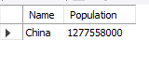

- Capital of Spain: Scenario: A travel agency is organising tours across Europe and needs accurate information on capital cities. You're tasked with identifying the capital of Spain from the database to ensure itinerary accuracy and provide travellers with essential destination information.

SELECT city.ID, city.name, city.CountryCode
FROM city
INNER JOIN country ON city.ID=country.capital
WHERE Countrycode="ESP";

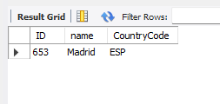

- Cities in Europe: Scenario: A European cultural exchange program is seeking to connect students with cities across the continent. You're tasked with compiling a list of cities located in Europe from the database to facilitate program planning and student engagement.
SELECT city.ID, city.name, city.CountryCode, country.Continent
FROM city
INNER JOIN country ON city.CountryCode=country.code
WHERE Continent="EUROPE";

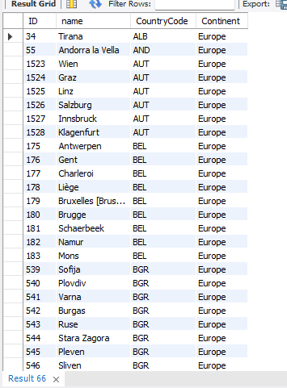

- Average Population by Country: Scenario: A demographic research team is conducting a comparative analysis of population distributions across countries. You're tasked with calculating the average population for each country from the database to provide valuable insights into global population trends.

SELECT AVG(Population), NAME
FROM country
GROUP BY Name;

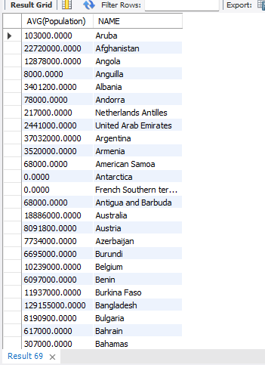

- Capital Cities Population Comparison: Scenario: A statistical analysis firm is examining population distributions between capital cities worldwide. You're tasked with comparing the populations of capital cities from different countries to identify trends and patterns in urban demographics.

SELECT city.ID, city.name AS City, city.Population, country.capital, country.name AS Country
FROM city
INNER JOIN country ON city.ID=country.capital;

